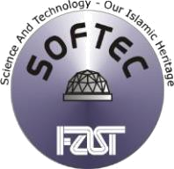
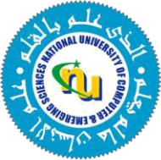
NATIONAL UNIVERSITY
of Computer &Emerging Sciences

SOFTEC Society, FAST-NU

Block-B, Faisal Town, Lahore, Pakistan

E-Mail: info@softecnu.org
www.softecnu.org

To,

Mr. Akhtar Abbas

Subject: Invitation for SOFTEC 2020 as Chief Guest on Ideas Xtreme Closing Ceremony

Respected Sir,

We, at SOFTEC, cordially invite you as the honorable Chief Guest on closing ceremony of Ideas Xtreme (SOFTEC) 2019, a renowned annual I.T. extravaganza organized by student body of FAST-NU Lahore, on 28th and 29th March 2019.

Since its beginning in 1995, SOFTEC has grown to be the largest I.T. festival across Pakistan, hosting the best of national and international I.T. events that contribute immensely to the advancement of science and technology in Pakistan and are a forum for students and globally notable professionals to come together and bridge the gap between academia and the I.T. industry.

The major aim behind the Ideas Xtreme is to provide a platform which encourages innovation, recognizes talent and provides opportunities for school level students to showcase their skills through an idea regarding a theme to help make this world a better place. It allows them to be aware of the environmental problems and think to the best of their abilities about the solutions.

Considering your honorable position, we humbly request you to spare some time from your busy schedule and grace the event with your presence as Chief Guest at the Closing Ceremony of Ideas Xtreme on the 24th edition of SOFTEC this year, on 29th March 2020 from 2:00pm to 3:30pm and address the future pioneers of I.T. in Pakistan.

We look forward to your response and would be honored to receive you at SOFTEC 2020.

Regards,

Muhammad Saad Zaheer Ihtesham Ahmed
President Head Ideas Xtreme
SOFTEC 2020 SOFTEC 2020
0332-7207798

Foundation for Advancement of Science & Technology

